19.47: a) We aren’t told whether the pressure increases or decreases in process bc. The cycle could be

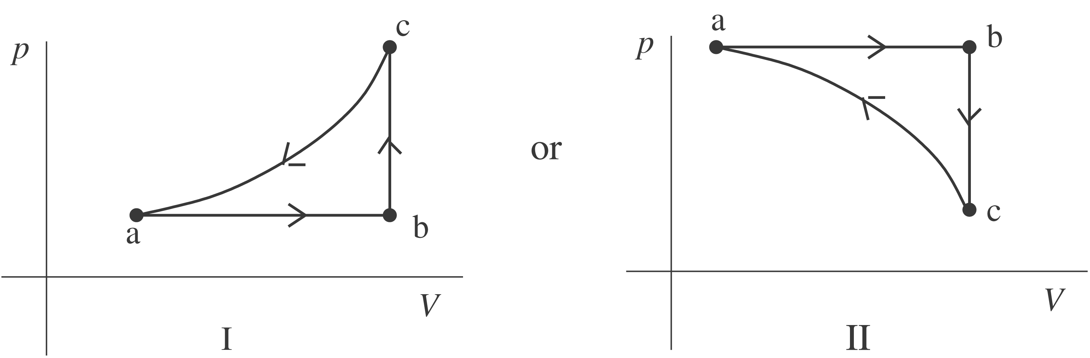

In cycle I, the total work is negative and in cycle II the total work is positive. For a cycle, 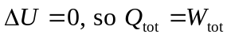
The net heat flow for the cycle is out of the gas, so heat 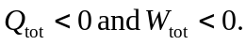Sketch I is correct.
b) 

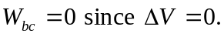
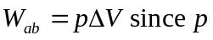 is constant. But since it is an ideal gas, 